Dari terminal / ctrl F3

Pilih user root

Passwordnya changeme

Kemudian kita ganti passwordnya

Menjadi 123456

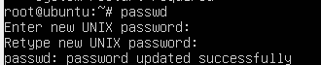

Sekarang install

Sudo apt install apache2 -> kalau pakai user biasa

Kalau pakai root tidak pakai sudo

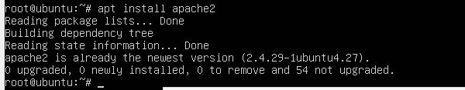

Di informasinya sudah bisa,

Bisa pakai browser untuk cek

Karena pertemuan kemarin sudah diinstall

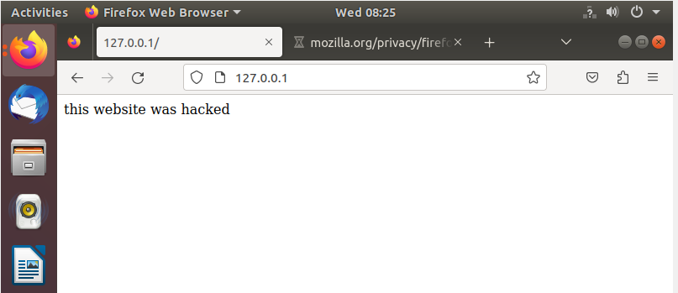

Sekarang install mysql server

sudo apt install mysql-server

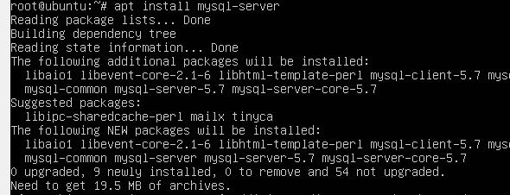

Problem

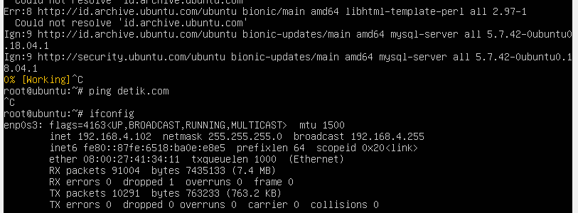

Ubuntu tidak dapat koneksi internet

Ubah network nya menjadi NAT

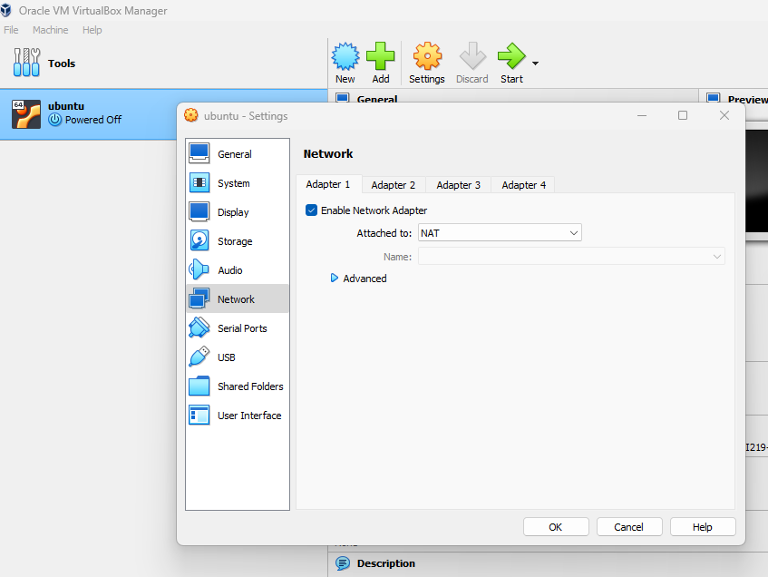

Start lagi ubuntu nya

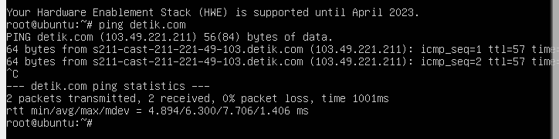

Coba lagi

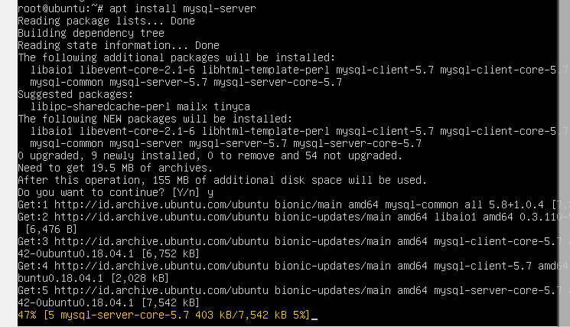

Sudah selesai diinstall

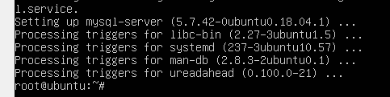

Kemduian tahap ini

sudo mysql_secure_installation

Upon running this command, you will be prompted to answer a series of question by entering either the letter ***Y*** or the letter ***n***and then hitting the enter key.

Here are the questions you will be asked along with the corresponding answers:

VALIDATE PASSWORD COMPONENT can be used to test passwords and improve security. It checks the strength of password and allows the users to set only those passwords which are secure enough. Would you like to setup VALIDATE PASSWORD component?

Press y|Y for Yes, any other key for No:

If you answer ***yes***, you will be asked to set a level of password validation (where 2 is the strongest level and will require all passwords to contain numbers, upper, lowercase letters and special characters, etc. Regardless of what you choose here, you will then have to set a password for your MySQL database.

**Remove anonymous users? [Y/n]**

Purely for the purposes of testing all MariaDB installations come with an anonymous user (this makes it possible to log into MariaDB without having a user account ready to use). Since this is for testing and not advised for servers that are being used in production, you’re going to want to go ahead and remove the anonymous users by replying ***Y*** here.

**Disallow root login remotely? [Y/n]**

In single-server setups the database only needs to be accessible by this server (which would be considered localhost access as opposed to *remote*access). Therefore, this can be disabled by responding ***Y***.

**Remove test database and access to it? [Y/n]**

Respond ***Y***to this step to simply remove the tables and ensure that the database is empty and ready for us to install WordPress later.

**Reload privilege tables now? [Y/n]**

And last but not least, respond **Y**here.

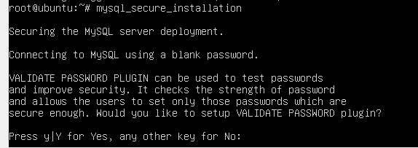

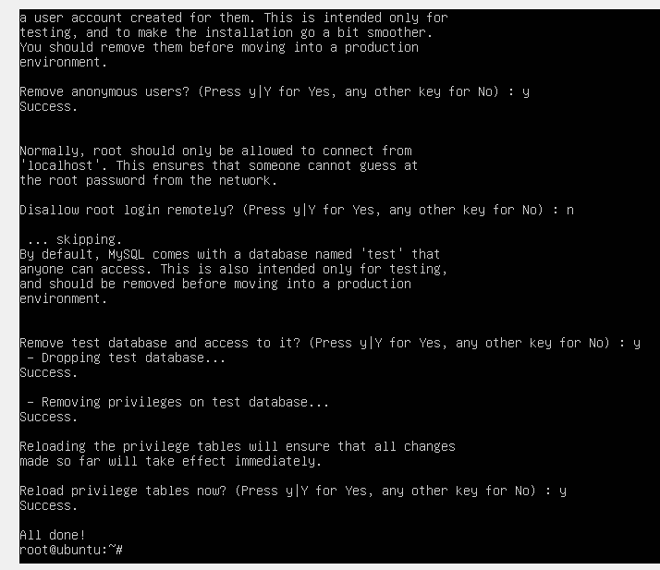

Tahap secure admin sudah ..saya pilih low dan password 123456..karena hanya di lab

Kemudian isntall php

sudo apt install php libapache2-mod-php php-mysql

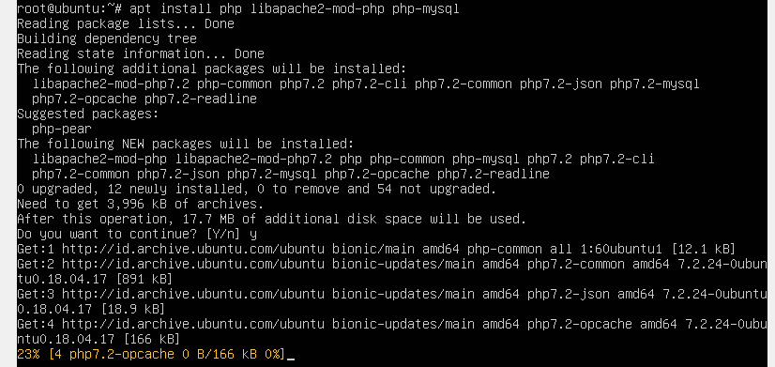

Sudah selesai install php

Kemudian ada library yang perlu diinstall, supaya memudahkan dalam penggunaan wordpress

Yaitu isntall

sudo apt install php-curl php-gd php-mbstring php-xml php-xmlrpc php-soap php-intl php-zip

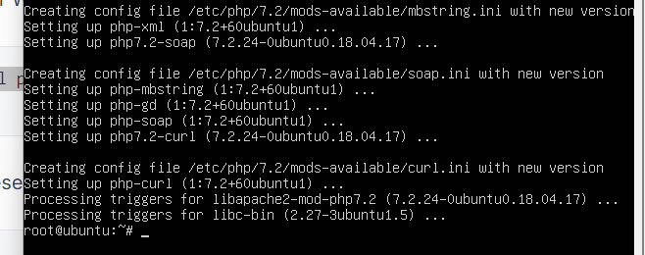

Restart apache nya

sudo systemctl restart apache2



Suapaya mudah install databasenya

Ktia lakukan install phpmyadmin

1. sudo apt install phpmyadmin php-mbstring php-zip php-gd php-json php-curl
2. kalau php-mbstring php-zip php-gd php-json php-curl sudah diinstall sebelumnya , cukup apt install phpmyadmin